Pathways to Wellness Associates: Acupuncture: Health History

Name (first, last): |  | DOB:
Address (street): |  | Gender: Female or Male
Address (town, state): | Phone #:
Email address: | Occupation:
Emergency Contact (name, number):
Primary care physician:

Main Complaint:
Main complaint:

When did it start? | Severity: 1 (minimal) –------------------ 10 (high)
What makes it better and worse:

Lifestyle:
Cups of water/day: | Caffeine/day:
Alcohol/day/week: | Tobacco use:
Diet (breakfast, lunch, dinner):
Exercise routine: | Energy level 1 (low) – 10 (high):
Emotions: happy, sad, anxious, shy/timid, worried, angry, irritable | Sudden Energy drop:
Current medication/vitamins/supplements:

Injury, surgery, hospitalization:
Allergies:

Personal Medical History:
Asthma | Seizure/fainting | Cancer | Stroke
Heart disease | High or low blood pressure | Edema | Hepatitis
Thyroid disease | Sexually transmitted disease | Crohn’s | Diverticulitis
Ulcerative colitis | Gallbladder disease/removal | Kidney stones | Weight gain or loss
Psoriasis/eczema | Rheumatoid arthritis | Diabetes | High cholesterol
Body temperature:
Cold ----------------neutral----------------hot  Cold hands and feet? | Night sweats:  Hot flashes:  Sweat easily:

Sleep:
# Hours/night | Difficulty falling asleep | Wake to urinate
 | Difficulty staying asleep | Rested in AM

Headache, eyes, ears:
Location | Dull | Throbbing | Sharp | Heavy
Migraine | TMJ pain | Dizziness | Vertigo | Poor memory
Poor vision | Floaters | Dry /itchy eyes | Ringing ears | Cataracts

Mouth and throat:
Thirst (cold or hot) | Dry mouth | Bleeding gums | Unusual taste | Sore throat

Chest:
Prone to colds | Chronic cough | Color of phlegm | Difficult breathing
Pneumonia | Bronchitis | Asthma | COPD/Emphysema

Digestion:
Gas after meals | Bloating | Full easily | Indigestion
Strong/low appetite | Acid reflux | Stomach pain | Nausea /vomit

Bowel movements:
# Bowel/day | Formed or loose | Diarrhea | Constipation | Hemorrhoid
Foul smelling | Blood | Mucus | Irritable Bowel Syndrome

Urination:
Frequent | Incontinence | Dribbling | Wake at night | Color of urine
Clouded | Blood | Burning | Strong odor

OB/GYN:
Pregnant | # Live births | # Miscarriages | Irregular cycle
Birth control | Age of 1st period | Length of period | Length of cycle (start to start)
Painful periods | PMS symptoms | Headache/period | Fatigue/period

Quality of blood  (thin, thick, clots) | Color of blood (pale, bright, dark, brown, purple) | Bleeding between periods

Vaginal discharge | Yeast infection | Endometriosis | STD
Cyst | Fibroid | Hysterectomy | HPV

Menopause:
Age of menopause | Hot flash | Night sweat | Vaginal dryness | Osteoporosis

Men reproduction:
Loss of sex drive | Impotence | Prostate cancer | Testicular pain/swelling

Pain: Shade area(s) of pain:
Better/worse with heat/cold
Better/worse with movement
Better/worse with pressure

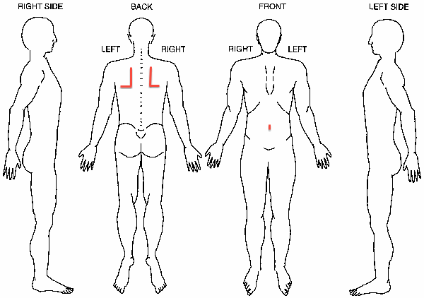

(For the acupuncturist to complete)
Initial Diagnosis:

Initial Treatment:

Initial Treatment Plan:

